**ASSIGNMENT 2**

|  |  |
| --- | --- |
| Assignment Date | 14 th September 2022 |
| Student Name | Bharathi G |
| Student Roll Number | 950819104011 |
| Maximum Marks | 2 Marks |

1. Write a flask program which should display Name , Email, phone and it should display the same details once we hit submit.

**Solution**

display.py

from flask import Flask,render_template,request

app = Flask(__name__)

@app.route('/')

def home():

    return render_template('details.html')

@app.route('/display',methods=['POST'])

def display():

    name = request.form['name']

    email = request.form['email']

    phone = request.form['phone']

    str = "Name : "+name+"<br>Email : "+email+"<br>Phone : "+phone

    return str

if __name__=='__main__':

    app.run(debug=True)

templates/details.html

<!DOCTYPE html>

<html>

    <head>

        <meta charset="utf-8">

        <style>

            body{

                display:flex;

                justify-content:center;

                align-items:center;

                flex-direction:column;

            }

            form{

                display:flex;

                flex-direction:column;

                justify-content:center;

                align-items:center;

                padding:20px;

                border:1px solid black;

            }

            header{

                font-size:30px;

                padding:10px;

            }

        </style>

    </head>

    <body>

        <form action="/display" method="POST">

            <header>Details<hr></header>

            <div>

                <label>Name : </label><br><br>

                <input name="name" id="name" type="text" />

            </div><br>

            <div>

                <label>Email ID :</label><br><br>

                <input name="email" id="email" type="text" />

            </div><br>

            <div>

                <label>Phone Number : </label><br><br>

                <input name="phone" id="phone" type="text" />

            </div><br>

            <input type="submit" value="Submit"/>

        </form>

    </body>

</html>

**Output:**

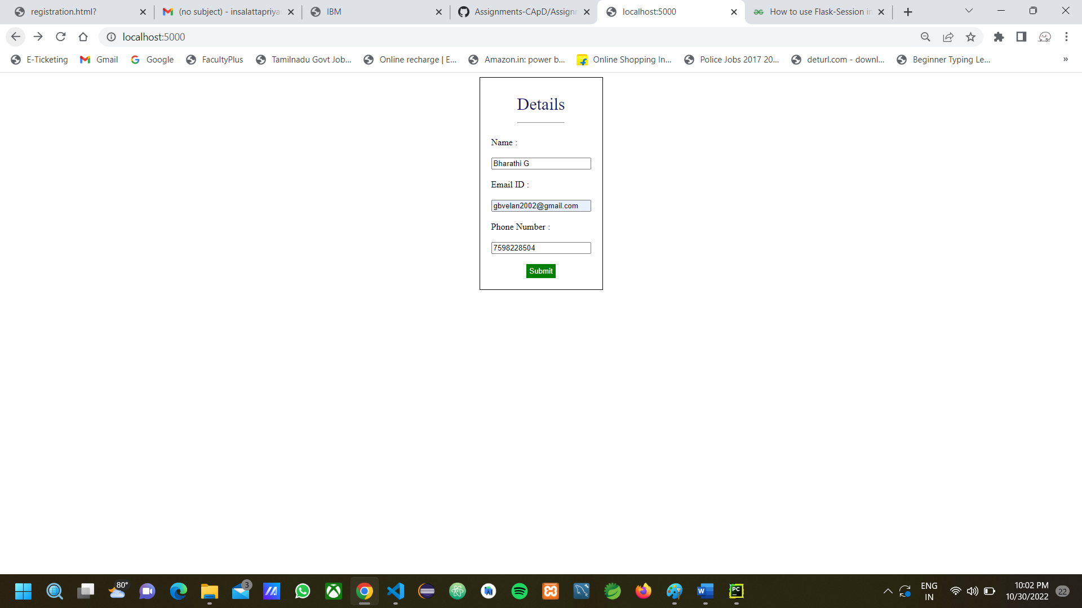

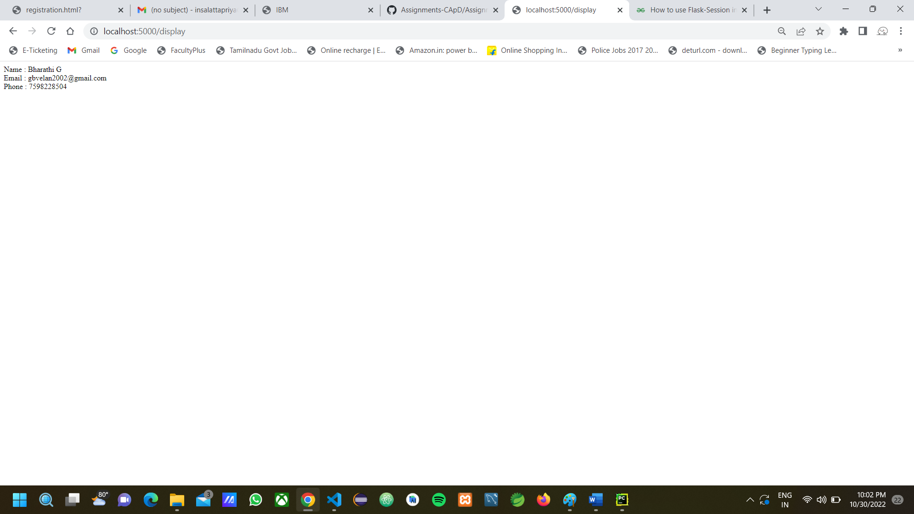

1. Write a flask program which should cover cookies, sessions

**Solution:**

**Cookies**

cookies.py

from flask import *

app = Flask(__name__)

@app.route('/')

def setCookie():

    res = make_response("Cookie is set")

    res.set_cookie('Flask','Framework')

    return res

if __name__ == '__main__':

    app.run(debug=True)

**Output:**

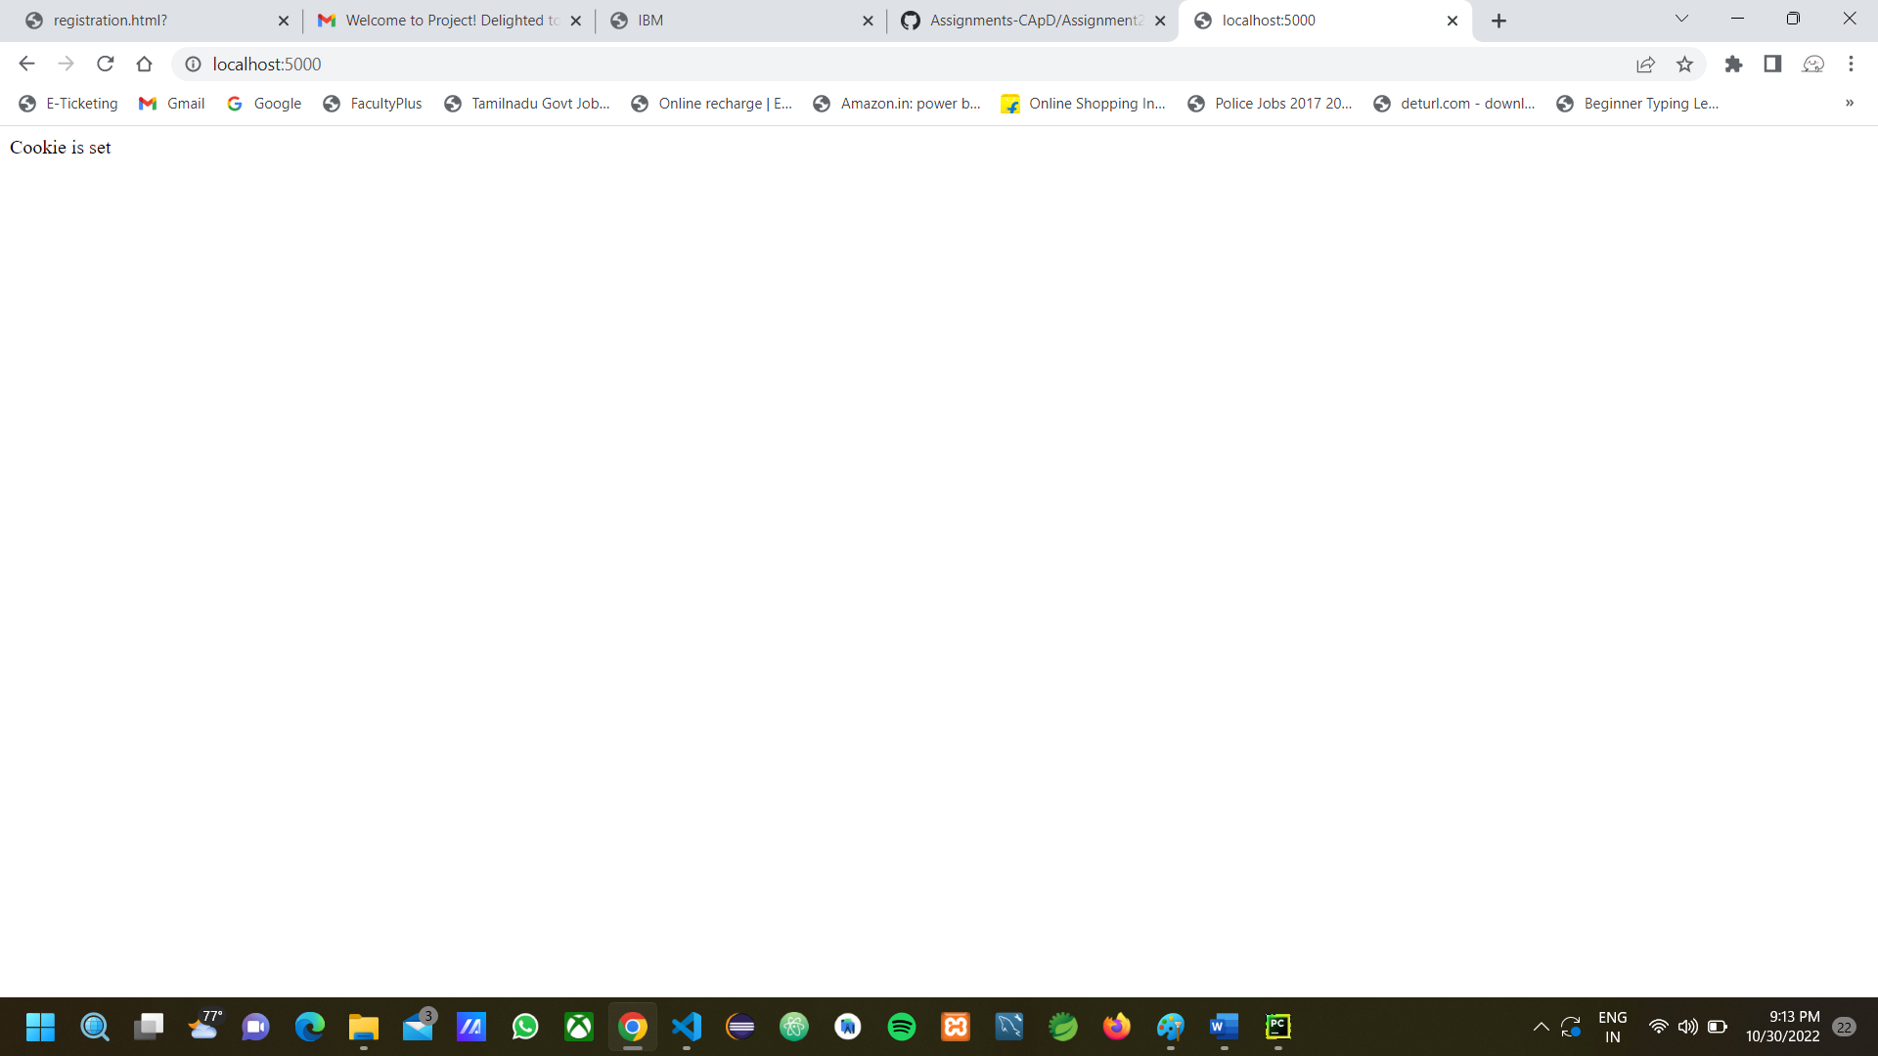

**Session**

session.py

from flask import Flask, render_template, redirect, request, session

# The Session instance is not used for direct access, you should always use flask.session

from flask_session import Session

app = Flask(__name__)

app.config["SESSION_PERMANENT"] = False

app.config["SESSION_TYPE"] = "filesystem"

Session(app)

@app.route("/")

def index():

    if not session.get("name"):

        return redirect("/login")

    return render_template('index.html')

@app.route("/login", methods=["POST", "GET"])

def login():

    if request.method == "POST":

        session["name"] = request.form.get("name")

        return redirect("/")

    return render_template("login.html")

@app.route("/logout")

def logout():

    session["name"] = None

    return redirect("/")

if __name__ == "__main__":

    app.run(debug=True)

templates/index.html

<!DOCTYPE html>

<html>

    <head>

        <meta charset="UTF-8">

    </head>

    <body>

        <div>You are registered {{session.name}}</div><a href="/logout" >logout</a>

    </body>

</html>

templates/login.html

<!DOCTYPE html>

<html>

    <head>

        <meta charset="UTF-8">

    </head>

    <body>

    <h1> REGISTER </h1>

   <form action="/login" method="POST">

      <input placeholder="Name" autocomplete="off" type="text" name="name">

      <input type="submit" name="Register">

   </form>

    </body>

</html>

**Output:**

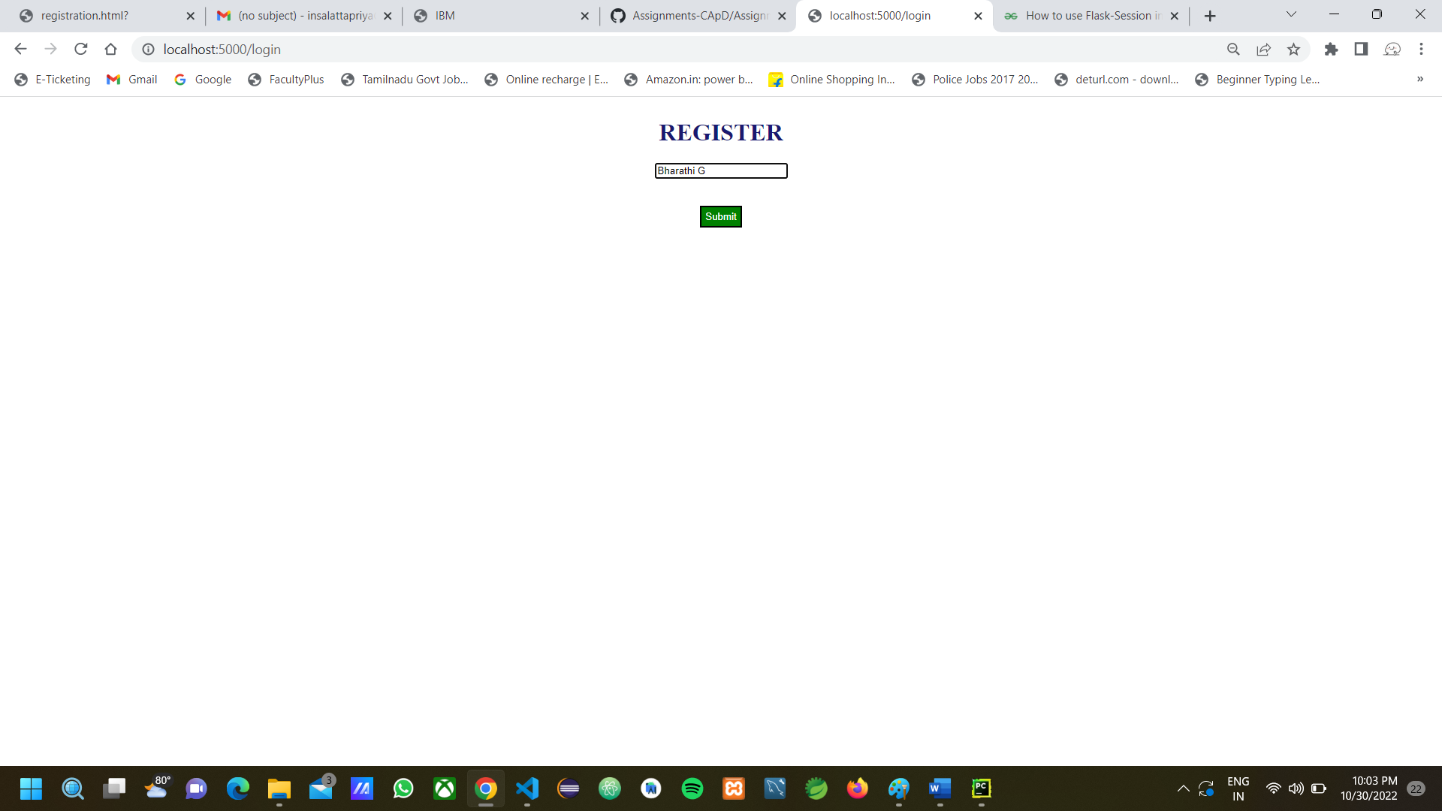

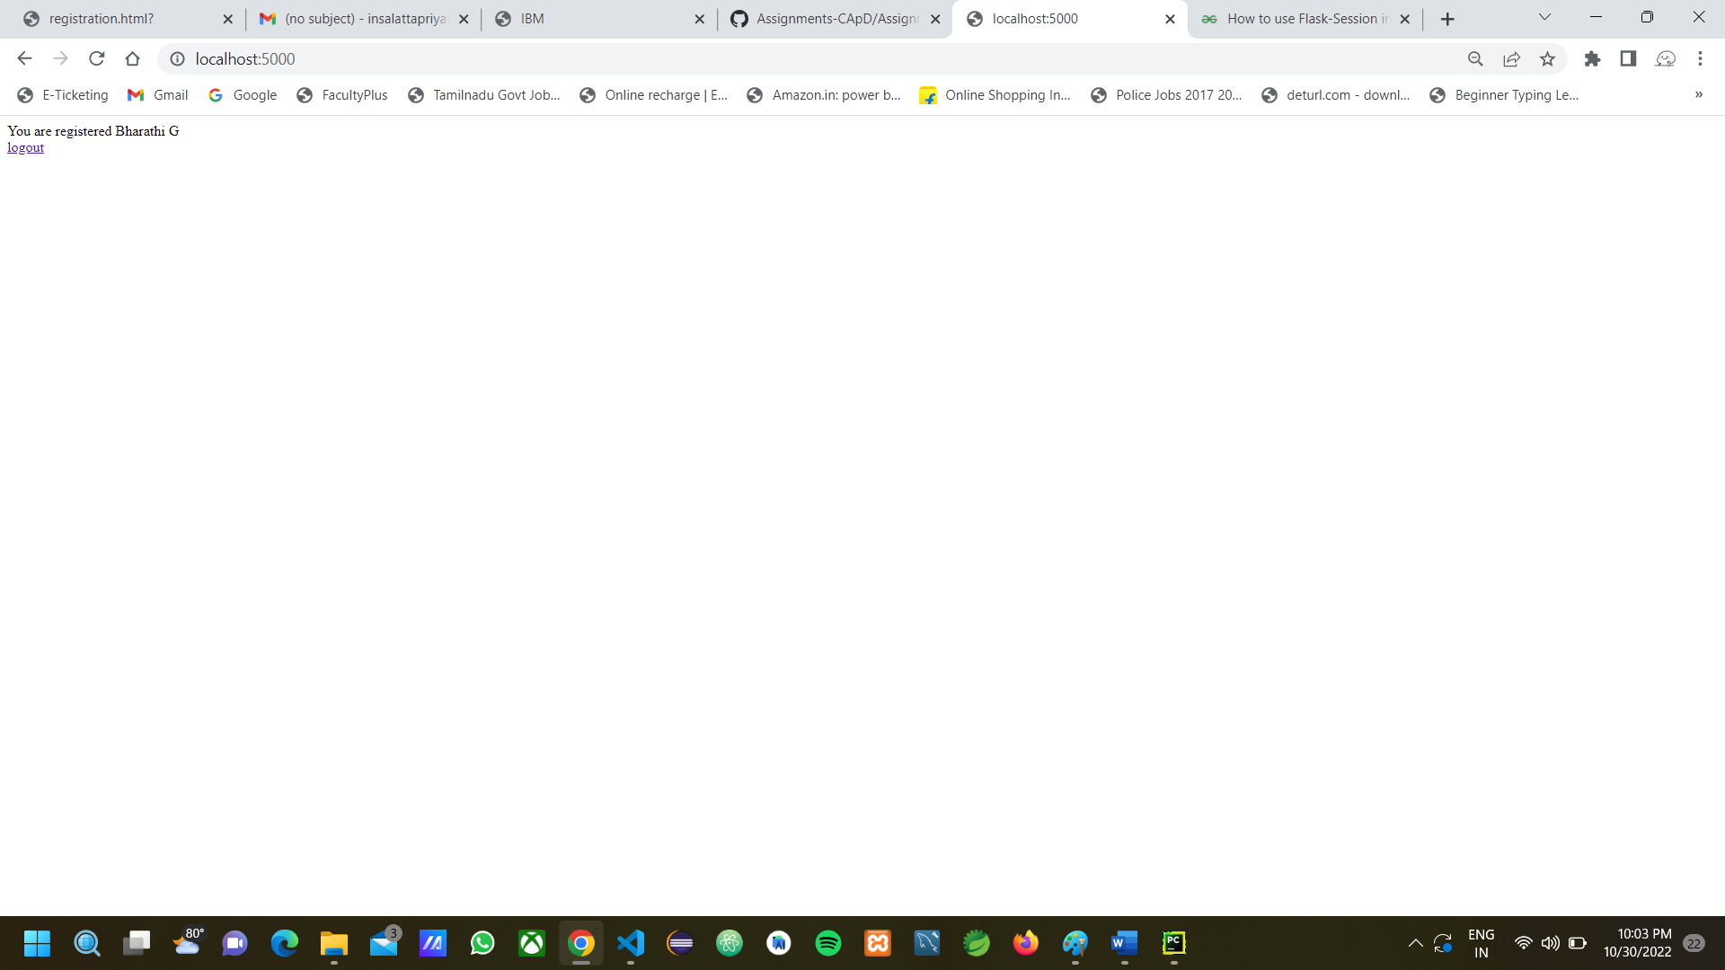

1. Write a flask program which should display resume details and have a upload resume option by using file uploading.

**Solution:**

resume.py

from flask import Flask,request,render_template

from werkzeug.utils import secure_filename

app = Flask(__name__)

@app.route('/')

def home():

    return render_template('resume.html')

@app.route('/upload',methods=['POST'])

def fileUpload():

    f = request.files['file']

    f.save(secure_filename(f.filename))

    return "File Uploaded Successfully"

if __name__=='__main__':

    app.run(debug=True)

templates/resume.html

<!DOCTYPE html>

<html>

    <head>

        <meta charset="UTF-8">

        <style>

            body{

                font-family:Helvetica;

                display:flex;

                justify-content:center;

                align-items:center;

                flex-direction:column;

            }

            .resume{

                padding:10px;

                width:800px;

                border:3px solid black;

            }

            div{

                text-align:justify;

            }

            div,a,li{

                padding:5px;

            }

            .header{

                text-align:center;

            }

            .right{

                margin-left:20px;

            }

            .file{

                padding:10px;

                margin:10px;

            }

            .submit{

                text-align:center;

            }

        </style>

    </head>

    <body>

        <form method="POST" action="/upload" enctype="multipart/form-data">

            <label ><b>Upload Resume : </b></label>

            <input class="file" name="file" type="file" value="Upload" /><br>

            <div class="submit">

                <input class="file" type="submit" value="Upload">

            </div>

        </form>

        <form class="resume">

            <div class="header">

                <h1>Bharathi G</h1><hr>

                <div><b>Address :</b>3/804-7,Zion Nagar Theri Road, Pudukottai,Thoothukudi-628103.Tamil Nadu. </div>

                <div><b>Phone :</b>9626326941 </div>

                <div><b>Email :</b>gbvelan2002@gmail.com</div>

            </div>

            <div>

                <h2>Summary</h2>

                <div class="right">A self-motivated, hard-working and positive student looking for a fresher position. I am looking to explore

mycareer options in IT sector which provides an opportunity to expand my knowledge as a computer science

graduate.

                </div>

            </div>

            <div>

                <h2>Education</h2>

                <div class="right">

                    <h3>Government College of Engineering, Tirunelveli</h3>

                    <div>Bachelor of Engineering - BE, Computer Science</div>

                    <div>2019 - 2023</div>

                    <h3>CGPA : 9.22</h3>

                </div>

                <div class="right">

                    <h3>St.Joseph's Matric Hr Sec School. Thoothukudi</h3>

                    <div>HSC, Maths Biology</div>

                    <div>Jun 2017 - Mar 2019</div>

                    <h3>Percentage : 87.5%</h3>

                </div>

                <div class="right">

                    <h3>St.Joseph's Matric Hr Sec School. Thoothukudi</h3>

                    <div>SSC</div>

                    <div>Jun 2016 - Mar 2017</div>

                    <h3>Percentage : 97.5%</h3>

                </div>

            </div>

            <div>

                <h2>License And Certifications</h2>

                <ul>

                    <li>Responsive Web Design - freeCodeCamp</li>

                    <li>Programming in Java - NPTEL</li>

                </ul>

            </div>

            <div>

                <h2>Skills</h2>

                <ul>

                    <li>Java</li>

                    <li>C</li>

                    <li>Javascript</li>

                    <li>Angular</li>

                    <li>Node.js</li>

                    <li>HTML5</li>

                    <li>CSS3</li>

                </ul>

            </div>

            <div>

                <h2>Projects</h2>

                <div class="right">

                    FACE MASK DETECTION using Python-Opencv - Photography

 Detect the person who are not wearing mask in public places

                </div>

                <div class="right">

                    Online Car Sells Website using Angular js

 Website to sell/buy an old and brand new cars.

                </div><br>

            </div>

            <div>

                <h2>Hobbies</h2>

                <ul>

                    <li>Photography</li>

                    <li>Planting Trees</li>

                </ul>

            </div>

        </form>

    </body>

</html>

**Output:**

